CURRICULUM VITAE

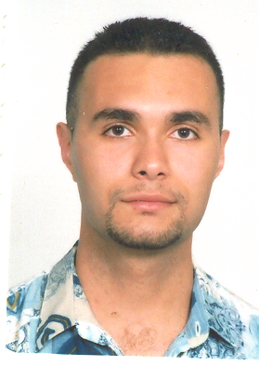

PERSONAL DATA:

Name : Ben Younes Mohamed Achraf
Date and place of birth: 02/16/1984 La Marsa
Marital Status: Single
Address: 20 Rue Ali Bach Hamba La Marsa
Cell phone: (00216)22125658
E-mail : achrafbenyounes@gmail.com

EDUCATION AND DIPLOMAS:

- 2010-2011: Master Degree in Common Law
- 2009-2010: First year degree of Post Graduate Studies in Common Law with grade “good” (FSJPST).
- 2008-2009: BA in Legal Sciences, Faculty of Legal, Political and Social Sciences, (FSJPST) Tunis.
- 2006-2007: First Cycle University Studies Certificate in Legal Sciences, Faculty of Legal, Political and Social Sciences (FSJPST) Tunis.
- 2004-2005: Baccalaureate Certificate session June 2005, with grade “good”.

TRAINING:

- September 2009 – October 2009: Training in “Legal English” within the AMIDEAST as part of master courses in Common law.
• I participated in the Eighteenth Annual Willem C .VIS International commercial Arbitration Moot Vienne Austria 15-21 April 2011
I participated in the 1st Middle East Pre- Moot to be held in Vienna 11-13 April 2011

PROFESSIONAL EXPERIENCES:

2006- untill now | Customer Care Advisor (Orascom Telecom Tunisie Tunisiana)

SKILLS AND PROFICIENCY

- Work out the reports of the interviews.
- Work within a team successfully.
- Excellent organizational, interpersonal and communication skills in three languages (Arabic, French and English).
- Proficiency in writing in three languages.
- Active, serious, dynamic,

LANGUAGES

 | Arabic | French | English
Written | Excellent | Excellent | Excellent
Spoken | Fluent | Fluent | Fluent

HOBBIES

- Internet
- Reading
- Creative writing
- Listening to music
- Playing Volley Ball

