***C.V***

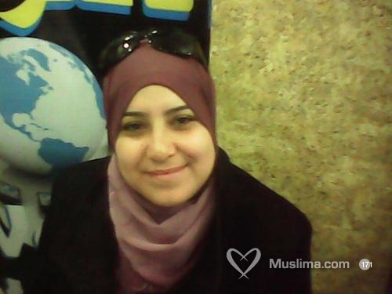

***Name: Matmati Raoudha***

***Date and place of birth: 02/09/1986 Bizerte***

***Address: City Sindibad Houmet Rymel Jarzouna Bizerte***

***Num Tel: 28 718 244/20 360 664***

***Mail: raoudhamatmati@yahoo.fr***

***Marital Status: celebataire***

***Nationality: Tunisian***

***My Education:***

***➢ 2007-2008: thers El Canel: Bachelor of Economics and Management.***

***➢ 2008-2010: Training Center Télécominications Cité El Khadra: Technician Diploma Professional Télécominications options instalations and maintenance of corporate networks.***

***My courses:***

***➢ 02/02/2009au18/04/2009: Automatic Switching Centre (Belevedere): A good experience "applications in the central" CCA ".***

***➢ 01/09/2009 au29/09/2009: Automatic Switching Centre (Belevedere): A good experience "applications in the central" CCA ".***

***➢ 08/02/2010au24/04/2010: Centre Transmissions Donnés (Belevedere): A good experience in the field of télécominications in the office of the central Tunis "CTD".***

***➢ 01/09/2010au 10/11/2010: Company "BHM" unpaid internship in the field infomatique "IT and administrative services."***

***Professional Experience:***

***➢ 05/02/2011 to 08/04/2012: A good working experience in the computer field (Arabic therapy, manipulation of the tool: word PowerPoint, Excel).***

***languages:***

***➢ Arabic: reading and writing***

***➢ Fracais: read and write***

***➢ English: reading and writing***

***interests:***

***Reading, Music, Cénéma, travel ....***