**CURRICULUM VITAE**

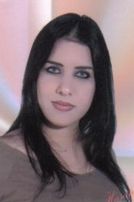 PERSONAL INFORMATIONS:

**Family name** : MANAA

**Name** : FATMA

**Date and Place of Birth** : 10/03/1982 in Mahres SFAX

**Mobile** : 00216 21 635 870

**Marital Status** : Single

**Adress** : 12 Rue Tokyo Mahres 3060 Sfax

**Email :fatmazahra1982@live.fr**

EDUCATION:

* 2001/2010: English Masters degree (Faculty of Arts and Sciences Humanities in Sfax )
* 2001: Bachelor (Art Section) Ali Bourguiba School Mahres Sfax

Work Experiences:

* Seasonal as a sales representative at the fair of agriculture in Sfax.
* Customer Services Agent in different Call centers in Tunis .
* A receptionist in Tamaris Hotel in Mahres Sfax.
* A secretary in a Building Company in Tunis.
* Customer Services Agent in HEXABYTE.

**LANGUAGES :**

|  |  |  |  |  |  |  |  |
| --- | --- | --- | --- | --- | --- | --- | --- |
| **WRITING** | | | | **Communication** | | | |
| **Excellent** | **Good** | **Average** | **Weak** | **Excellent** | **Good** | **Average** | **Weak** |
| **Arabic** | **X** |  |  |  | **X** |  |  |  |
| **French** | **X** |  |  |  | **X** |  |  |  |
| **English** | **X** |  |  |  | **X** |  |  |  |

**COMPUTER SKILLS :**

Microsoft office: Word, Excel, Access

Internet

**HOBBIES :**

Music

Sport