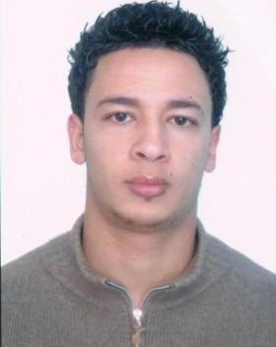***CURRICULUM VITAE***

Moslem MASTOURI

26 years old

133 Rue Bachar ibn Bord Cité El amal 2

Fouchana Ben Arous Tunisie 2082

Mob: 20719491

Email: [mastouri.moslem02@gmail.com](mailto:mastouri.moslem02@gmail.com)

**Career Objective :**

reach a job in a dynamic organization which allows me to combine my leadership and talents of communication with my aptitudes for the administration in order to put a business frofit and develop my competence

**Studies and Qualifications :**

**2012🡺2013**

***AMADEUS TRAINING CERTEFICATE***

**2009🡺2012**

***Bachelor Degree in the English Language and Literature***

⮚ *Name of the college*: higher institute of languages of Tunis (Bourguiba School)

**2005🡺2006**

***Baccalaureate of literature***

⮚ *Name of the college*: Cité Amal School – Fouchana

**Professional Experiences :**

**June 2011🡺December 2011**

*⮚ Post*: UK Customer Service “English”

*⮚ Name of the establishment*: "Vistaprint" Call Center

As a UK customer service I’m in charge of receiving calls from our UK Customers, the language is English, my job is to answer their inquiries and requests, assist them to place their orders online using different system and tools. As a UK customer service I’m also in charge of answering our UK Customers’ emails.

Our goal was to deal and interact with all type of customers and satisfy all their needs

**Summer2010**

*⮚ Post*: Receptionist

*⮚ Establishment*: LellaBaya Hotel Hammamet _TUNISIA

I was in charge of handling phone calls of our customers "inbound and outbound calls" as a receptionist i was accepting the booking of room reservations. I was also making sure that all our customers are satisfied and securing their well being. I was also in charge of securing payments.

**Computer skills :**

* Software skills

⮚ Word, Excel, Power point, Front page, Photoshop…

⮚ Internet

**Linguistic Knowledge :**

**English**: fluent (spoken and writing)French: fluent (spoken and writing )

**French**: fluent (spoken and writing )Arabic: mother tongue

**Arabic**: mother tongue

**FIELD OF APTITUDES AND PERSONAL COMPETENCES:**

⮚ Dynamic, creative, motivated, sociable, able to work in a multidisciplinary team

⮚Communication : good communication skills

**Activities & interests:**

⮚ Internet

⮚Travelling

⮚ Cinema and Theater

⮚Sports (Boxing, fitness, jogging)

**References:**

1 – VistaPrints Tunis – Les Berges du Lac

Akrem Ferjenni – Staff supervisor

71 45 76 78

2 – MegaSuccess Consultancy – Les Berges du Lac

Lee Hwong – HR director

71 86 02 60

3 – Hotel Lella Beya - Hammamet

Amir Ridane – HR director

72 24 08 88