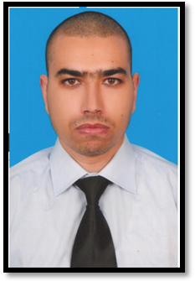

Samir Masrouki
Mobile: 00216 98 932 787
samirmasrouki@yahoo.fr

SUMMARY

Profile: Male, 34, Single
Date of Birth: 28 / 04 / 1979
Preferred Locations: All GCC Countries, Libya, Iraq

WORK EXPERIENCE


Oct 2012 – Aug 2013 Lootah group of Companies, Dubai, UAE
Security Manager
- Responsible for the overall operations and administration of Safety / Security group of
Companies.
- Constantly monitor all area of operations, training, logistics, administration and manpower
situation of the directorate and be on top of the problems.
- Ensure that the Safety / Security operations Directorate is managed in the most effective
and efficient manner.
- Major crises and emergencies, expected to be the Incident Commander and make
quick and prompt decisions in order to resolve the situations in a timely manner.
- Direct and control the proper implementation of day-to-day operations and administration
of the Safety / Security operations
- Directorate, and to carry out periodic reviews to maintain their effectiveness and currency.
- Prepare Ops orders/instructions and all relevant procedures and ensure that they are
Complied with by his staff.
- Handles security studies, plans and audits, and also threat risk assessments.
- Conduct site survey and work out manpower deployment and resource allocation.
- Constantly monitor the area of operations, training, logistics, and manpower availability
pertaining to protection services.
- Conduct security surveys and supervisory checks for Safety / Security group of
companies.
- Review and recommend improvements to the current operational methodology,
procedures and policies to ensure maximum operational efficiency and alignment to the
company’s vision.

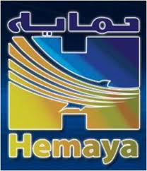
Oct 2009 - May 2012 Hemaya Security Services Company - Doha, Qatar
Head of Planning and Organization Section
- Plan, develop and implement the security services department strategy for the
management of the department operations so as to meet agreed company performance
plans within agreed budgets and timescales
- Monitor measure and report to the Manager on operational issues, opportunities and
development plans
- Ensure the development of new policies and doctrines and ensure the continued relevance
and adequacy of the existing department security policies and doctrines
- Identify new organizational initiatives and performance goals/targets
- Plan manage and control the department work plans, annual expenditure & budgets
- Plan for adequate and uninterrupted supply of personnel, vehicles and equipment to
maintain efficient operations
- Manage and control the activities of the Policies & Doctrines, Manpower Planning
Succession and the logistics Review & Acquisition Officers
- Ensure that operational activities of the department meet with organizational requirements
for quality management, health & safety and legal stipulations
- Preparation of tenders.


Nov 2005 - Jul 2009 Inter-con Security Systems of Tunisia LTD & Hotels
Security In Charge
- Prepare Security Studies
- Monitoring VIP movements - Escorting
- Responsible security operations (embassies, foreign companies and foreign residences)
- Emergency and bomb procedures

- Manage security supervisors Team
- Responsible training and professional development
- Responsible access control and CCTV.
- Monitoring of incident reports.
- Liaise and Coordination with police agencies.
- Monitoring the correct application of safety procedures.
- Monitor and review levels of manpower staffing to ensure that they are adequate for
current operations and new projects and assignments
- Monitoring and Follow-up of company targets
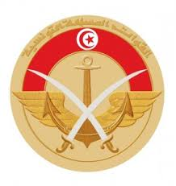
Oct 1999 - Oct 2005 Navy,
Military
- Coach Martial Arts in Army.
- Ensuring the security of athletes at sea
- Member of ensuring the security building of Ministry of Defense.
- Responsible Security Military sea Port.
- Responsible security training

CERTIFICATES

2000 Marines (Military)
2008 C.E.F.E
2009 National Certificate in Ambulance (Paramedic)
2011 International Certificate, Economics of Security Services, Performance Quality and Risk Management, (London - United Kingdom)
2012 International Certificate, Taekwondo Black Belt, (Korea)
2014 NEBOSH – IGC, International General Certificate in Occupational Health and Safety (United Kingdom)

SKILLS

•Administrative skills
•Emergency Handling and Preparedness
•Problem Solving & Decision Making skills
•Knowledge of policies and security procedures
•Planning, Organizing and Training Skills

LANGUAGES

French Fluent
English Working knowledge

COMMENTS

Participate in securing the Arab Games in Doha 2011
Valid QATARI , UAE & TUN Driving License
Height 187 cm, Weight 92 kg

